 |  | 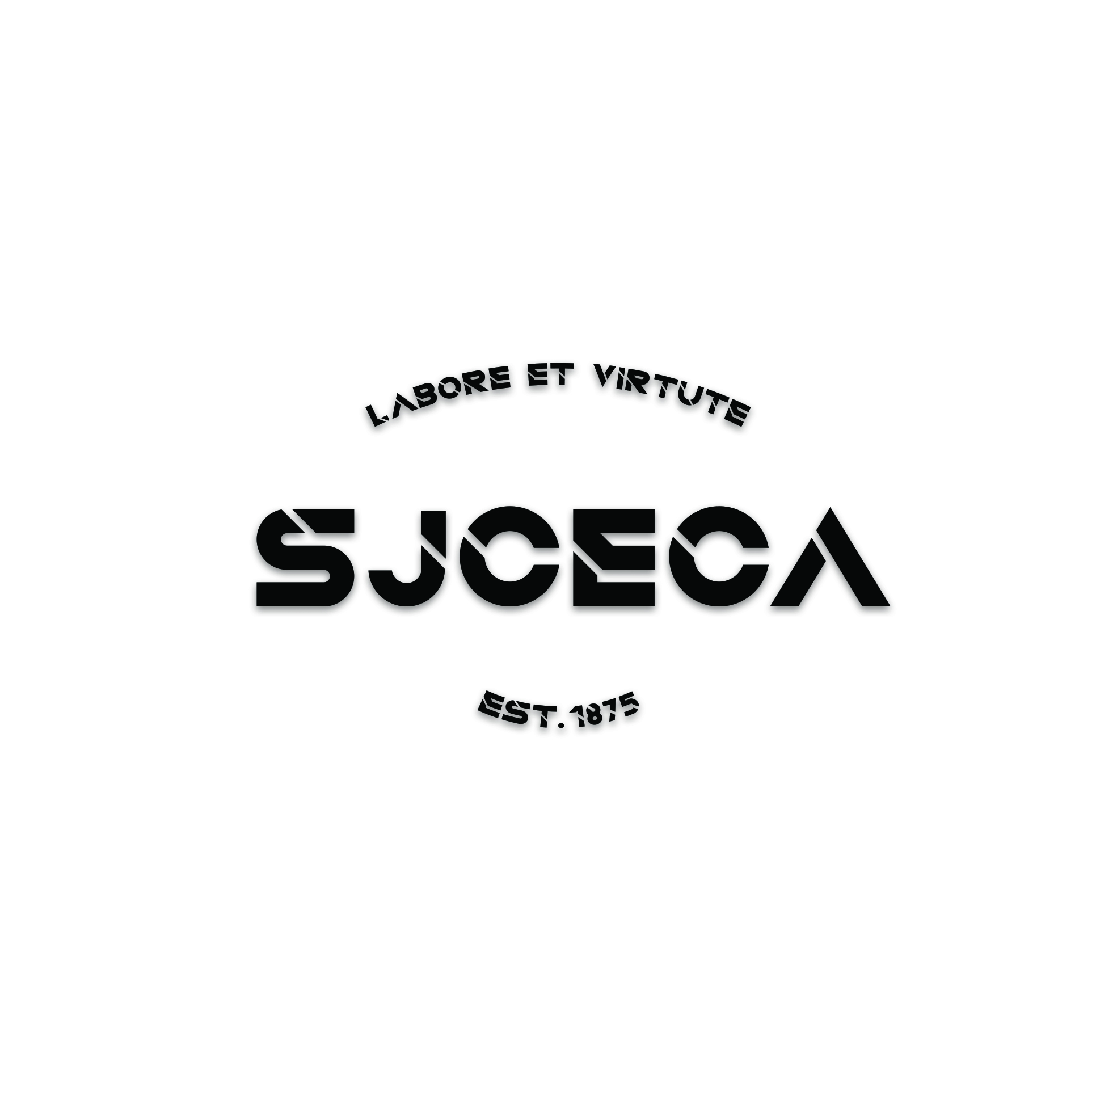  St. Joseph's College  Form C  Extra-curricular Activities Department  Choose an item.

Part I: Details of Function
Title:
Club/Society
Date / Period:
Time:
Part II: Checklist
☐Yearly Proposal  [Deadline: 2/10] | ☐Interim Report  [Deadline: 20/1] | ☐Annual Report  [Deadline: 30/6]
☐Committee List  ☐Budget  ☐Activities  (Each club/society should organize at least 4 activities throughout the year; the first activity must be held in the 1st semester)  (For sports group, training course must be provided for members.)  ☐Activity for ECA Week  ☐Activity in May for the La Salle exchange programme  ☐Whole-form Activity  ☐Joint-school Activity  ☐Joint-club Activity  ☐Community Service | ☐Introduction  ☐Recruitment Week Report  ☐Activities Report  ☐Financial Report  ☐Committee List  ☐Member List  ☐Conclusion | ☐Introduction  ☐Annual Evaluation Report  ☐Recommendation for New ex-co  ☐Committee List  ☐Member List  ☐Conclusion  THEME FOR 2025-26  “Our Country, Our Heritage, Our Future”
Part III: Approval by ECA Department
Approved by: |  |  | Ref. No.: ECA2526
For Religious & Service Groups,  ________________________  (Date: )  Ms Christy Sung | For Academic Groups,  ________________________  (Date: )  Ms Annabelle Fok | For Interests and Sports Groups,  ________________________  (Date: )  Mr David Chu | Additional Remarks:
Final Approved by:
_____________________________(Date: )
Mr Jeffrey Yim
ECA Master

This document is prepared by:
Student Name: | Mobile: | Class: S | No.:
St. Joseph's College
[Type your club name]
Year Plan 2025-26

(TEMPLATE FOR YEAR PLAN)
- OBJECTIVE/ MISSION

THEME FOR 2025-2026
“Our Country, Our Heritage, Our Future”

- SUPERVISING TEACHERS
Teacher-in-charge
Teacher Advisor

- EXECUTIVE COMMITTEES

Number of Executive Committees | Requirement
$$≤7$$ | Fulfill ECA requirement
8-10 | Fulfill ECA requirement  + ONE of the following activities:  whole-form activity/ community service/ joint-club event
11-13 | Fulfill ECA requirement  + TWO of the following activities:  whole-form activity/ community service/ joint-school event

Post | Name | Class (No.)

- GENERAL DUTIES OF EXECUTIVE COMMITTEES

Post | Duties

- ACTIVITIES TO BE HELD
(Each club/society should organize at least 4 activities throughout the year; the first activity must be held in the 1st semester. For sports group, training course must be provided for members.)

- Name of the event
Description of the event:  [minimum 50 words] | Recruitment Week
Aim:
PIC:
Date:
Venue:
Budget:

- Name of the event
Description of the event:  [minimum 50 words] | Activities for the ECA Week (3 – 14 NOV) (COMPULSORY)
Aim:
PIC:
Date:
Venue:
Budget:

- Name of the event
Description of the event:  [minimum 50 words] | Chinese Cultural Week (2 – 13 FEB)
Aim:
PIC:
Date:
Venue:
Budget:

- Name of the event
Description of the event:
[minimum 50 words]
Aim:
PIC:
Date:
Venue:
Budget:

- Name of the event
Description of the event:  [minimum 50 words] | La Salle exchange programme
Aim:
PIC:
Date:
Venue:
Budget:

- BUDGET

- CONCLUSION

Signed by,
_________________________
[Student Name] [Class] [No.]
Student-in-Charge
_________________________  [Teacher Name]  Teacher Advisor | _________________________  [Teacher Name]  Teacher-in-Charge

