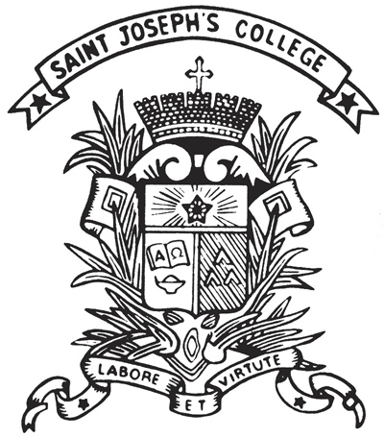 | St. Joseph's College  Form C  Extra-curricular Activities Department  2022-23 Choose an item.

Part I: Details of Function
Title:
Club/Society
Date / Period:
Time:
Part II: Checklist
☐Yearly Proposal  [Deadline: 30/9] | ☐Interim Report  [Deadline: 13/1] | ☐Annual Report  [Deadline: 29/5]
☐Committee List  ☐Budget  ☐Activities (Each club/society should organize at least 4 activities throughout the year; the first activity must be held in the 1st semester)  (For sports group, training course must be provided for members.)  ☐Activity for ECA Week  ☐Whole-form Activity  ☐Joint-school Activity  ☐Joint-club Activity  ☐Community Service | ☐Introduction  ☐Recruitment Week Report  ☐Activities Report  ☐Financial Report  ☐Committee List  ☐Member List  ☐Conclusion | ☐Introduction  ☐Annual Evaluation Report  ☐Recommendation for New ex-co  ☐Committee List  ☐Member List  ☐Conclusion
Part III: Approval by ECA Department
Approved by:
For Academic, Religious, Service Groups,  ____________________ (Date: )  Mr. Yim Jeffrey  ECA Vice Chairman | For Interest and Sports Groups,  __________________ (Date: )  Mr. Chu David  ECA Secretary | Additional Remarks:
Final Approved by:
_____________________________(Date: )
Mr. Tam C Y
ECA Master

This document is prepared by:
Student Name: | Mobile: | Class: S | No.:
St. Joseph's College
[Type your club name]
Year Plan 2022-23

(TEMPLATE FOR YEAR PLAN)
- OBJECTIVE/ MISSION

- SUPERVISING TEACHERS
Teacher-in-charge
Teacher Advisor

- EXECUTIVE COMMITTEES

Number of Executive Committees | Requirement
$$≤7$$ | Fulfill ECA requirement
8-10 | Fulfill ECA requirement  + ONE of the following activities:  whole-form activity/ community service/ joint-club event
11-13 | Fulfill ECA requirement  + TWO of the following activities:  whole-form activity/ community service/ joint-school event

Post | Name | Class (No.)

- GENERAL DUTIES OF EXECUTIVE COMMITTEES

Post | Duties

- ACTIVITIES TO BE HELD
(Each club/society should organize at least 4 activities throughout the year; the first activity must be held in the 1st semester. For sports group, training course must be provided for members.)

- Name of the event
Description of the event:  [minimum 50 words] | Recruitment Week
Aim:
PIC:
Date:
Venue:
Budget:

- Name of the event
Description of the event:  [minimum 50 words] | Activities for the ECA Week (NOV) (COMPULSORY)
Aim:
PIC:
Date: | First week of November
Venue:
Budget:

- Name of the event
Description of the event:
[minimum 50 words]
Aim:
PIC:
Date:
Venue:
Budget:

- Name of the event
Description of the event:
[minimum 50 words]
Aim:
PIC:
Date:
Venue:
Budget:

- Name of the event
Description of the event:
[minimum 50 words]
Aim:
PIC:
Date:
Venue:
Budget:

- BUDGET

- CONCLUSION

Signed by,
_________________________
[Student Name] [Class] [No.]
Student-in-Charge
_________________________  [Teacher Name]  Teacher Advisor | _________________________  [Teacher Name]  Teacher-in-Charge

