Form M
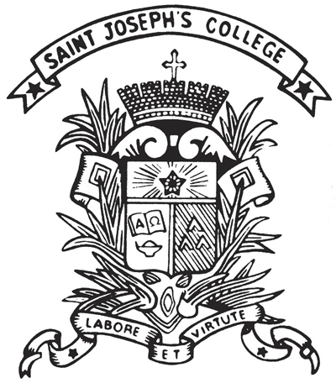 | St. Joseph's College  Extra-curricular Activities Department  Record for community service

Part I: Details of Function
Title:
Organizing Body:
Date / Period:
No. of Service Hours¹:
Ref. No.: | ECA_ _ _ _ _ _ _

Part II: Students’ Information
Class | No. | Name | Role* | No. of Hours²
*organizer, participant, coordinator
¹: maximum number of service hours of participating students
²: number of hours of specific participating students

Signed by,
______________________________________  [Student Name] [Class] [No.]  Student-in-Charge | _________________________________  [Teacher Name]  Teacher-in-Charge
______________________________________  5E Yuen Pui Him Albert/ Gabriel Chu Chun Ki  Community Service Coordinator | _________________________________  Kam Ryan  TIC of ECA Community Service

Part III: Supplementary Information

Photo 1 of the activity (Please input a photo): | Photo 2 of the activity (Please input a photo):
Description of Photo 1: | Description of Photo 2:

Link to Google Drive of activity photos:

