Form M
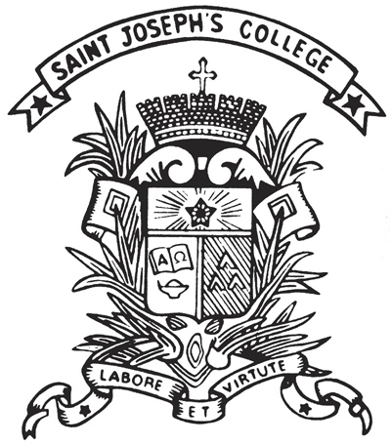 | St. Joseph's College  Extra-curricular Activities Department  Record for community service

Part I: Details of Function
Title:
Organizing Body:
Date / Period:
No. of service hours:
Ref. No.: | ECA1920_ _ _

Part II: Students’ Information
Class | No. | Name | Role*
*organizer, participant, coordinator

Signed by,
_________________________  [Student Name] [Class] [No.]  Student-in-Charge | _________________________  [Teacher Name]  Teacher-in-Charge
_________________________  5C Cheng Lucas/ 5C Pang Clifford  Community Service Coordinator | _________________________  Kam Ryan  TIC of ECA Community Service

