Form C
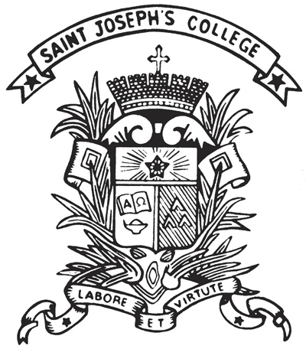 | St. Joseph's College  Extra-curricular Activities Department  2019-20 Choose an item.

Part I: Details of Function
Title:
Club/Society
Date / Period:
Time:

Part II: Checklist
☐Yearly Proposal | ☐Interim Report | ☐Annual Report
☐Committee List (max. 7)  ☐Budget  ☐Activities (Each club/society should organize at least 4 activities throughout the year; the first activity must be held in the 1st semester)  (For sports group, training course must be provided for members.)  ☐Activity for S1-2 students | ☐Recruitment Week Report  ☐Activities Report  ☐Financial Report  ☐Committee List  ☐Member List | ☐Annual Evaluation Report  ☐Recommendation for New ex-co  ☐Committee List  ☐Member List

Part III: Approval by ECA Department
Approved by: | Additional Remarks:
_____________________________(Date: )
Yeung Rani
ECA Secretary
Final Approved by:
_____________________________(Date: )
Tam C Y
ECA Master

This document will be scanned before returning to:
Student Name: | Class: S | No.:

Signed by,
_________________________
[Student Name] [Class] [No.]
Student-in-Charge
_________________________  [Teacher Name]  Teacher Advisor | _________________________  [Teacher Name]  Teacher-in-Charge

