Form J
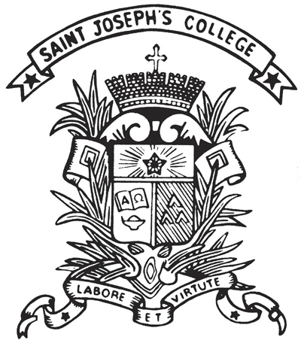 | St. Joseph's College  Extra-curricular Activities Committee  Minutes of __________ Meeting 2018-19

Part I: Meeting Specifics
Club / Organization:
Date:
Venue:
Time:
Objective:

Part II: Attendees Present
Chairperson:
Secretary:
Present: | Name Class (Class No.) Position
Apologies:

Part III: Agenda
The following were discussed in the meeting:

New business: (Upcoming events, New Ideas, Review of Calendar)

When is next meeting/event:

Adjournment: The meeting was adjourned at ______________ [time].

Respectfully Submitted by, Approved by,
_________________________  [Student Name] [Class] [No.]  Student-in-Charge | _________________________  [Teacher Name]  Teacher-in-Charge

